Creating Index
An alphabetical list of names, subjects etc. with reference to the pages/sections on which they are mentioned.
Entries can be created for different headings, let us see three different levels such as
- Main heading entry
- Sub-heading entry
- An entry for Sub-heading entry

Main Heading index
Step 1: Choose a word document for creating an index.
Step 2: On the menu bar, find an option called INDEX as shown in the figure below and click on CREATE Index.
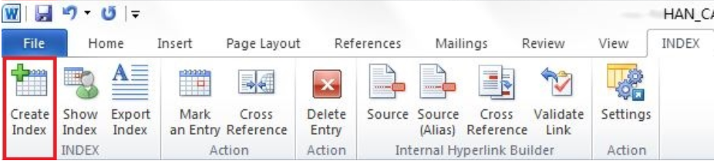
Step 3: When you click CREATE INDEX, a pop up box appears requesting to enter a new index name.
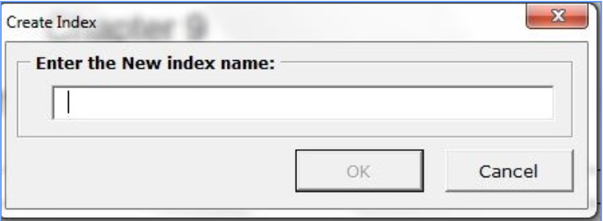
Step 4: Enter an index name and click OK.
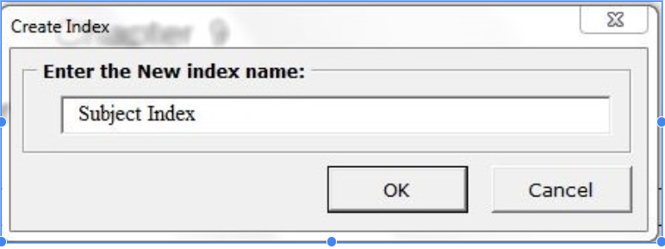
Step 5: The window of the word will split into two, one for marking the entries on various levels and the other for marking the references.
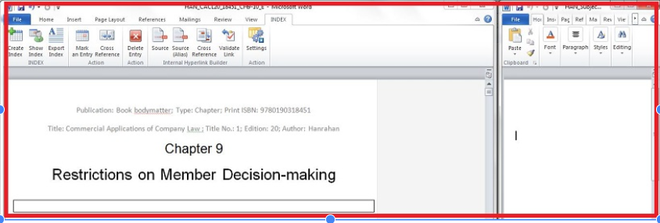
Step 6: For instance if I’m creating a reference for word shareholders in the document, select the word and click on Mark an Entry from INDEX menu.
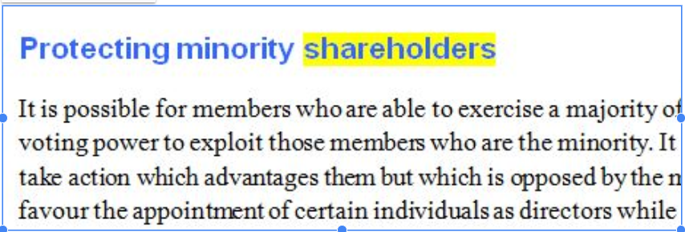
Step 7: After selecting the word, click on MARK an ENTRY as shown below,
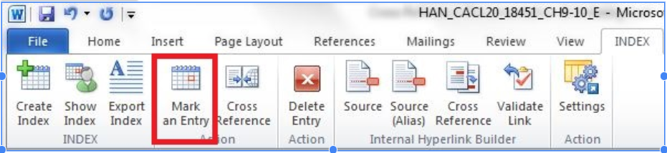
Step 8: We can customize the name of the chosen word for mark entry and since this is going to be the main entry, let us retain the same option.
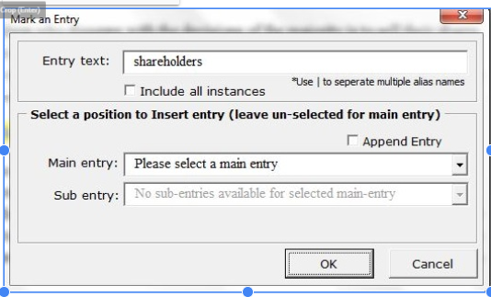
Step 9: When we submit by clicking OK, an index is created for the word.
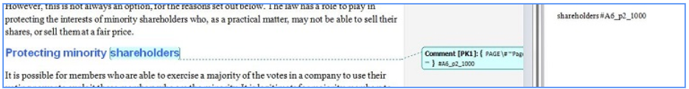

Step 10: We have created multiple main entries, kindly check below.
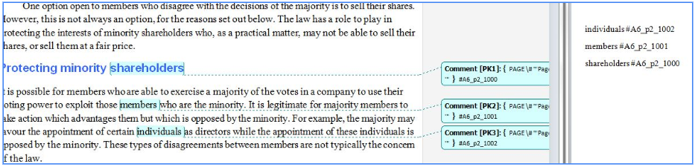

Note: This tool automatically SORTS the words in the index as we keep creating.
Step 11: Let us now create the sub-heading for the main entries.
Step 12: Here, we are going to create a sub heading for the main entry index INDIVIDUALS. For instance, select minority word for sub-heading.
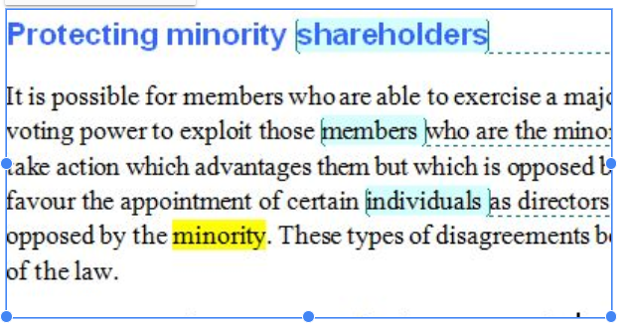

Step 13: Click on INDEX menu, in which select MARK ENTRY.
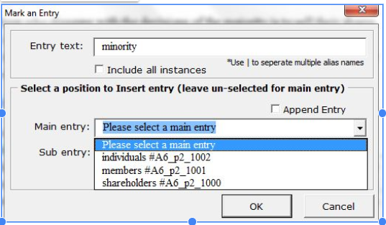
Step 14: In the main entry shown above we can select the main heading, here for example it is individuals #A6_p2_1002.
Step 15: The sub-heading has been created.
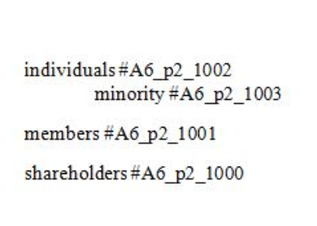

Step 16: Please find the below figure, for different sub-headings.
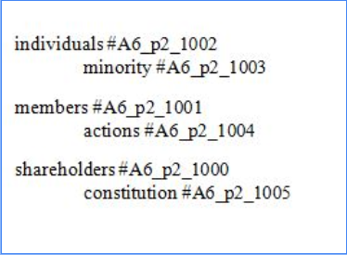
Step 17: Let us create third level sub-heading for individuals.
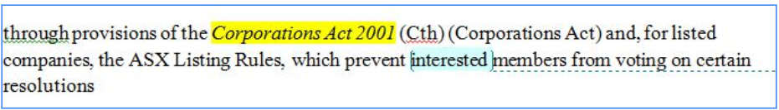
- Creating third level heading Corporation Act under Minority, which is under Main Entry Individuals.
Step 18: Select Corporations Act word as third level heading, and click on INDEX menu, and select MARK an ENTRY

- Select the main entry as INDIVIDUALS
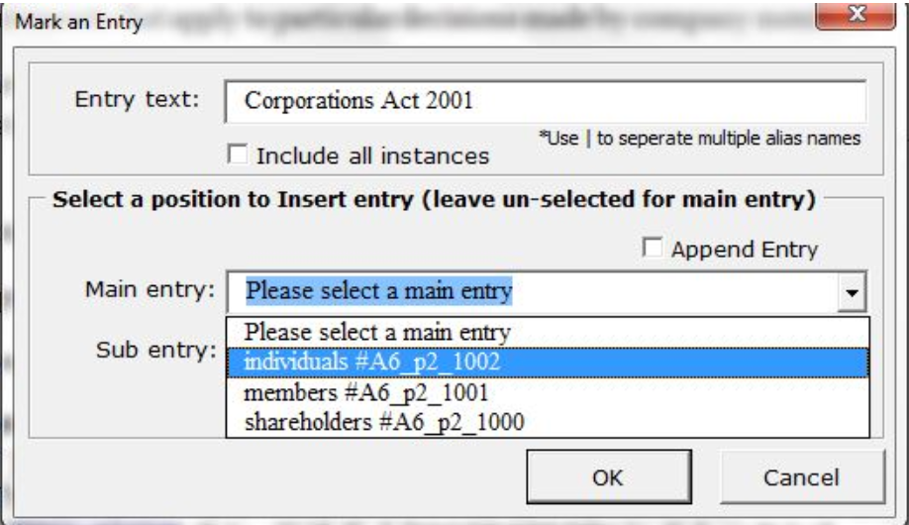

- Select the sub-entry as MINORITY.
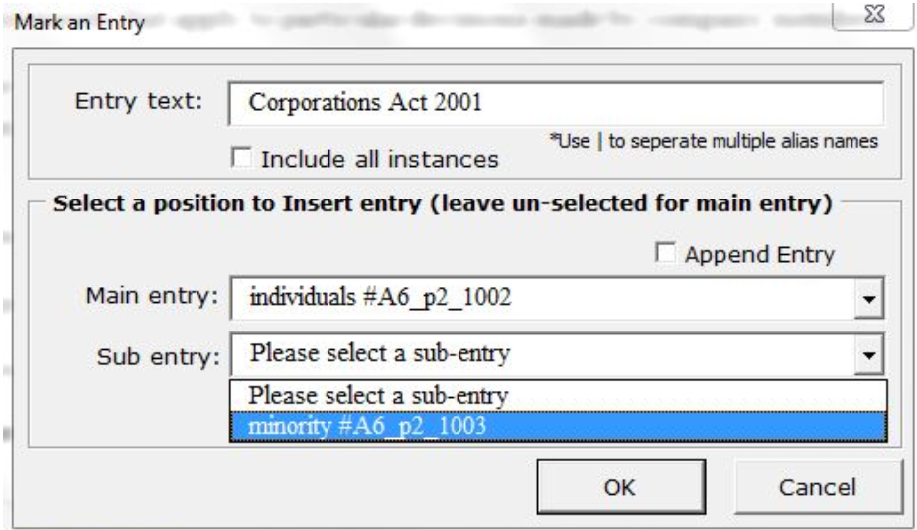

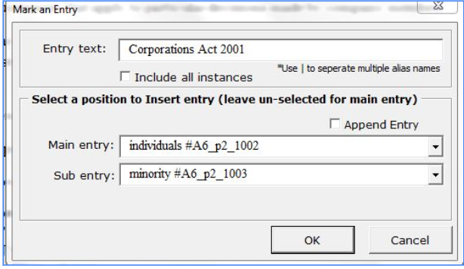
- Click OK, and the third level heading is created as below.
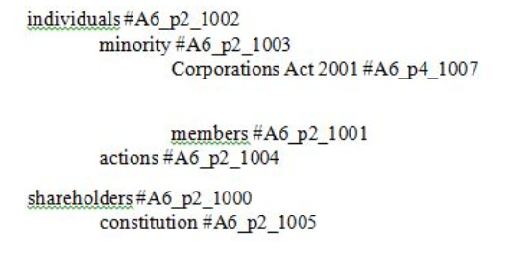
Step 19: So far we have completed seeing, on how to create a main entry, sub-entry and an entry inside the sub-entry (third level heading).

How to create a cross reference for the indexes?
Step 1: Select a word for creating the cross references within multiple documents inside a book for indexes.
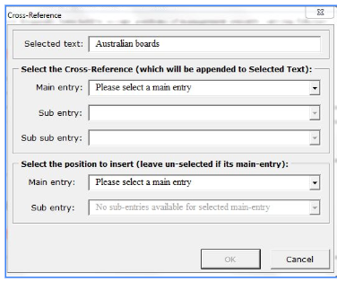
Step 2: Select the respective main entry and sub-entry and click OK.
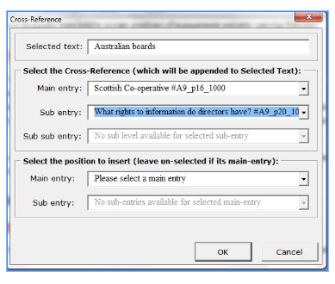

Step 3: The cross references for an index will be created like below.
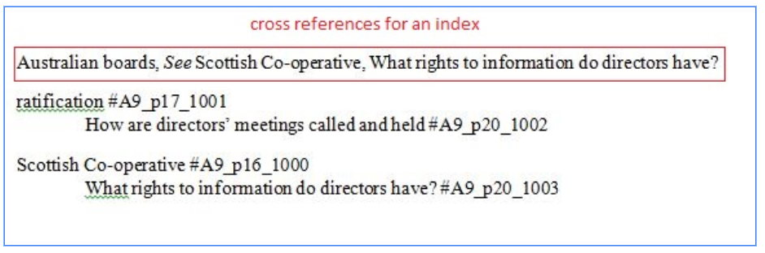
Creating index for repeated words in numerous pages shall get added up behind.
- For instance in our document we created an index entry for the word November.
- And, when we create another entry for the same word in different part of the document, id will get added up to the previously created id for November as shown below.
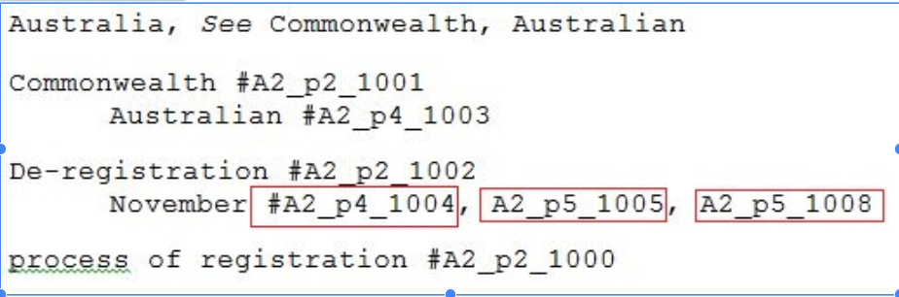

Creating entries using Alias name
Step 1: Enter the alias name as shown below and click OK
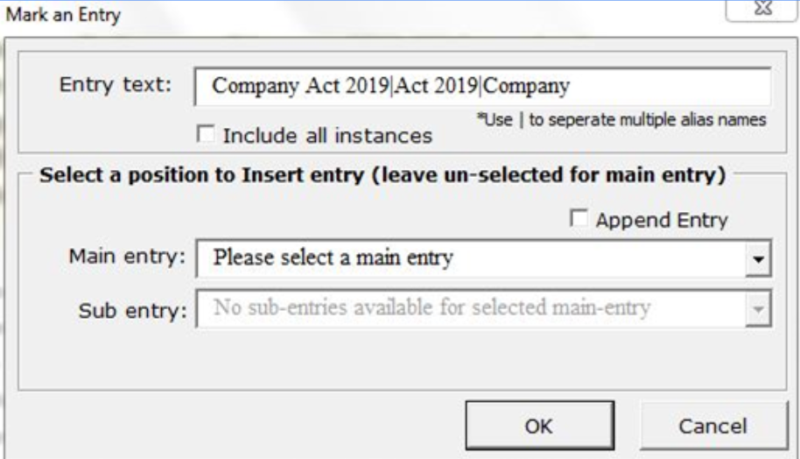
Step 2: An entry is created with the alias name
Company Act 2019|Company|Act 2019 #A3_p27_1007
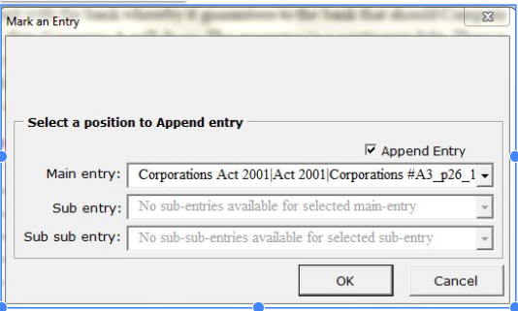
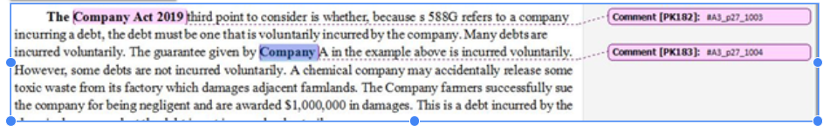
Step 3: Entries are appended as per the above image.
The version of index tool which we are using for this documentation is 12.4.

